**Ideation Phase**

**Define the Problem Statements**

|  |  |
| --- | --- |
| DATE | 26 September 2022 |
| TEAM ID | PNT2022TMID10134 |
| PROJECT TITLE | VirtualEye - Life Guard For Swimming Pools To Detect Active Drowning |
| MAXIMUM MARK | 2 Marks |

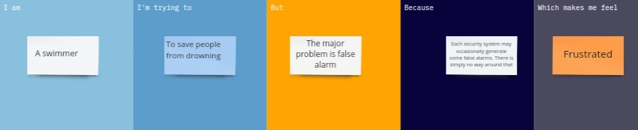

|  |  |
| --- | --- |
| **Problem Statement (PS):** | By studying body movement patterns and connecting cameras to artificial intelligence (AI) systems we can devise an underwater pool safety system that reduces the risk of drowning. Usually, such systems can be developed by installing more than 16 cameras underwater and ceiling and analyzing the video feeds to detect any anomalies. but AS a POC we make use of one camera that streams the video underwater and analyses the position of swimmers to assess the probability of drowning, if it is higher then an alert will be generated to attract lifeguards' attention. |
| **I am**  **(USER)** | A user, detect the drowning person in Swimming pools to alert the life guard |
| **I’m trying to** | Analyzing the body movement to Detect drowning people using a 16 cameras. And alert to life guard |
| **But** | I am not sure if I should alert the life guards he will rescue people |
| **Because** | It might cause many death in Swimming Pools increasing death rate |
| **Which makes me feel** | Children and begginer Swimmers may affect and leads to death. It will reduce by an VirtualEye cameras |